
IEEE International Conference on Smart Power, Energy, Renewables, and Transportation
(IEEE-SPERT 2025)

22 Dec - 24 Dec, 2025, Surat, Gujarat, INDIA





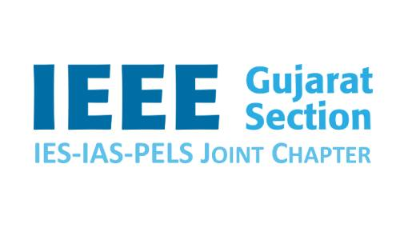


IEEE SPERT 2025 Special Session / Track Proposal
Title of the Proposal: xxxx

A brief description of the area of concern (With significance):
Max about 800 words also add how it is aligned to SPERT conference and different with the existing tracks

Details of Session Chairs/Organizers: Name, Photo, Brief bio (800 words max), Contact email
Organizers: Organizer 1:
Organizer 2:
Organizer 3:
Organizer 4:

Technical Outline of the Session and Topics:
Outline of the Session Tentative Topics of the Session
o xxx
o xxx
o xxx
:
Potential Contributing Authors (names, affiliations and emails):
o xxx
o xxx
o xxx
:
Potential Reviewers (names, affiliations and emails, at lease 20):
o xxx
o xxx
o xxx
:
Other Details (if any):
xxx.

